Petty Cash Application Project Go – Live Sign off


Petty Cash Application

Project Go-Live Sign off

Purpose

The Project Acceptance ensures that the deliverables, requirements, and expectations are met, approved, and accepted.


PROJECT/PHASE IDENTIFICATION

 |  | Project Name and Phase |  |  |  |  |  |  |  |  |  | CPI/Project Number |  |  |  |  |  | Project Type
 |  |  |  |  |  |  |  |  |  |  |  |  |  |  |  |  |  | (Business Consulting, Implementation,
 |  |  |  |  |  |  |  |  |  |  |  |  |  |  |  |  |  | Upgrade, Internal, other)
 |  | Petty Cash Application – Project Go Live sign off |  |  |  |  |  |  |  |  |  |  |  |  |  |  |  | Web Application
 |  | Customer Name |  |  |  |  |  |  |  |  |  | Customer Number |  |  |  |  |  | Planned Start/Finish
 |  | VKC group division 2
 |  | Project Sponsor |  |  |  |  |  |  |  | Program Manager |  |  |  |  |  | Project Manager (Customer)
 |  | VKC group division 2 |  |  |  |  |  |  |  | Mr.Jagadeesh |  |  |  |  |  | Mr.Gireesh
 |  | Project Manager (SAP) |  |  |  |  |  |  |  | SAP Service Partner(s) |  |  |  |  |  | Project Manager (Service Partner)
 |  |  |  |  |  |  |  |  |  | Mukesh Infoserve Private Ltd |  |  |  |  |  | Mr.Rajesh N
 | PHASE DELIVERABLE(S) DESCRIPTION
 |  | WBS # |  |  |  |  |  | Deliverable(s) |  |  |  |  |  | Receiving Organization |  |  |  |  |  | Date
 |  | WBS # |  |  |  |  |  |  |  |  |  |  |  |  |  |  |  |  | Submitted
 | 1. |  | Petty Cash Application gone Live successfully |  |  |  |  |  |  |  |  |  |  | VKC group division 2 |  |  |  |  | 29-08-2020

-
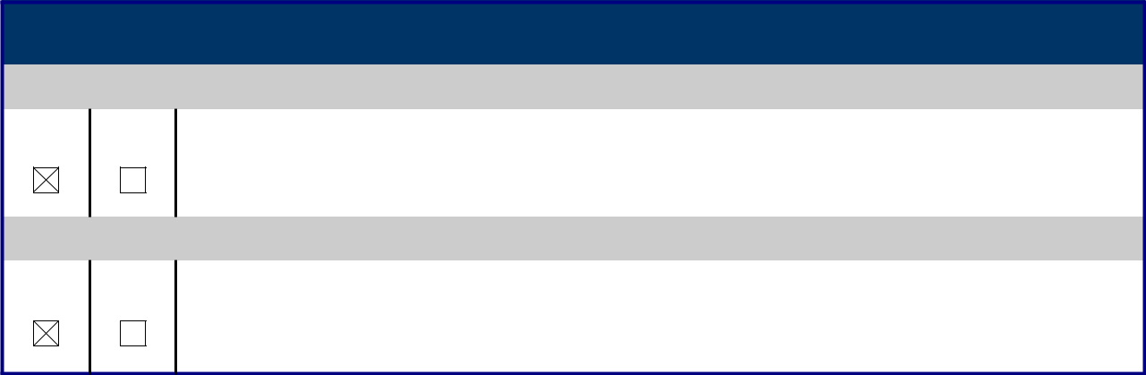

ACCEPTED BY

Project Manager, Customer

Yes | No Mr. Gireesh

Name Signature Date

Project Manager, Consulting

Yes | No Mr.Rajesh N

Name Signature Date

Page 1 of 1

